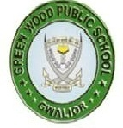
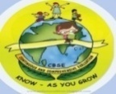
GREENWOOD PUBLIC SCHOOL, ADITYAPURAM
OUR MOTTO - DEVELOPMENT WITH DELIGHT
SYLLABUS FOR THE MONTH OF DECEMBER 2017-18
CLASS-L.K.G.
SUBJECTS |  | ACTIVITY+USE OF ICT | PARENTS INVOLVEMENT
English | Oral : Rhymes- Are you sleeping, Hop a little  Reading –Sounds of vowel ‘O’ , Revision of sounds of letters and words and use of a/ an  Written : Sounds of vowels ‘a’ and ‘e’ complete the words with the pictures, use of a/an revision of a-z, opposites , Dictation. | PPT on letters d-i (small cursive)  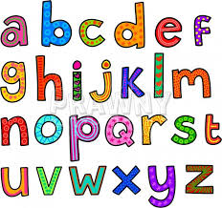 | Help your child in learning rhymes and written work
Hindi | Oral : dfork,¡ & आलू कचालू बेटा और पंखा  Reading – पठन पाठन- तीन वर्णो से बने शब्द , एकवचन / बहुवचन  Written : दो और तीन वर्णो से बने शब्द , विलोम शब्द और श्रुतलेख | Extra marks  o.kZekyk p ls u rd vkSj dfork,sa!  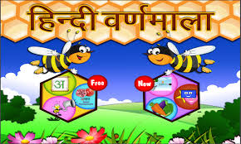 | dfork,sa ;kn djok,Wa rFkk o.kksaZ dh igpku fp=ksa +}kjk djok,W!
Maths | Oral : Number names 16-20, table of 5 counting 1-150  Written : Dictation ,table of 5 numbers name 11-15, addition , counting 1-150 | 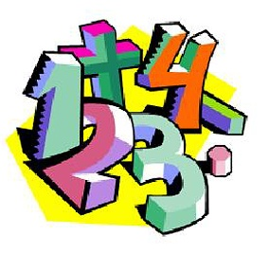  Extra marks  Videos on Number Names | Motivate your child in counting objects and learning tables.  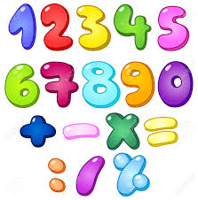
G.K. | Oral : Birds , Shelters of animals and our helpers. | PPT on colour chart and opposites | Help your child to recog. the colours
Music / Dance | Jingle bell, Jingle bell /
V.E. | Never argue with your elders. |  | Motivate your child to help others
Art & Craft | Fish, Lion and Frog
Sports | Football, Field games.
Language Development | Good Morning and have a great day ahead ,Stay blessed. |  | Help your child to develop good habits
Conversation | English Conversation  Five lines on my pet(cow)  - Cow is a pet animal.  - It gives us milk.  - It has four legs.  - It has a long tail.  - It is of white and brown colour.  Hindi Conversation  प्र १ पच्चीस दिसंबर को कौन सा त्यौहार मनाया जाता है ?  उ क्रिसमस  प्र २ हमारा राष्ट्रीय फूल कौन सा है ?  उ कमल  प्र ३ हमारा राष्ट्रीय पक्षी कौन सा है ?  उ मोर  प्र ४ आप किस शहर में रहते है ?  उ ग्वालियर  प्र ५ गाय हमें क्या देती है ?  उ दूध | 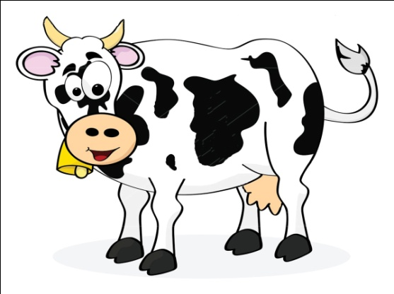 | Help your child in learning conversation Que/Ans

Activity Planner
Work Education  Health and Wellness  Performing Arts  Eco-club Activity | Making blue whale  Celebration of calcium day  Festival song  Green day celebration | Visit  Literary and Creative | Railway station  Story telling

